Análise de sobrevida.

https://portal.gdc.cancer.gov/exploration?facetTab=genes&filters=%7B%22op%22%3A%22and%22%2C%22content%22%3A%5B%7B%22op%22%3A%22in%22%2C%22content%22%3A%7B%22field%22%3A%22cases.primary_site%22%2C%22value%22%3A%5B%22Skin%22%5D%7D%7D%2C%7B%22op%22%3A%22in%22%2C%22content%22%3A%7B%22field%22%3A%22cases.project.program.name%22%2C%22value%22%3A%5B%22TCGA%22%5D%7D%7D%5D%7D&searchTableTab=genes

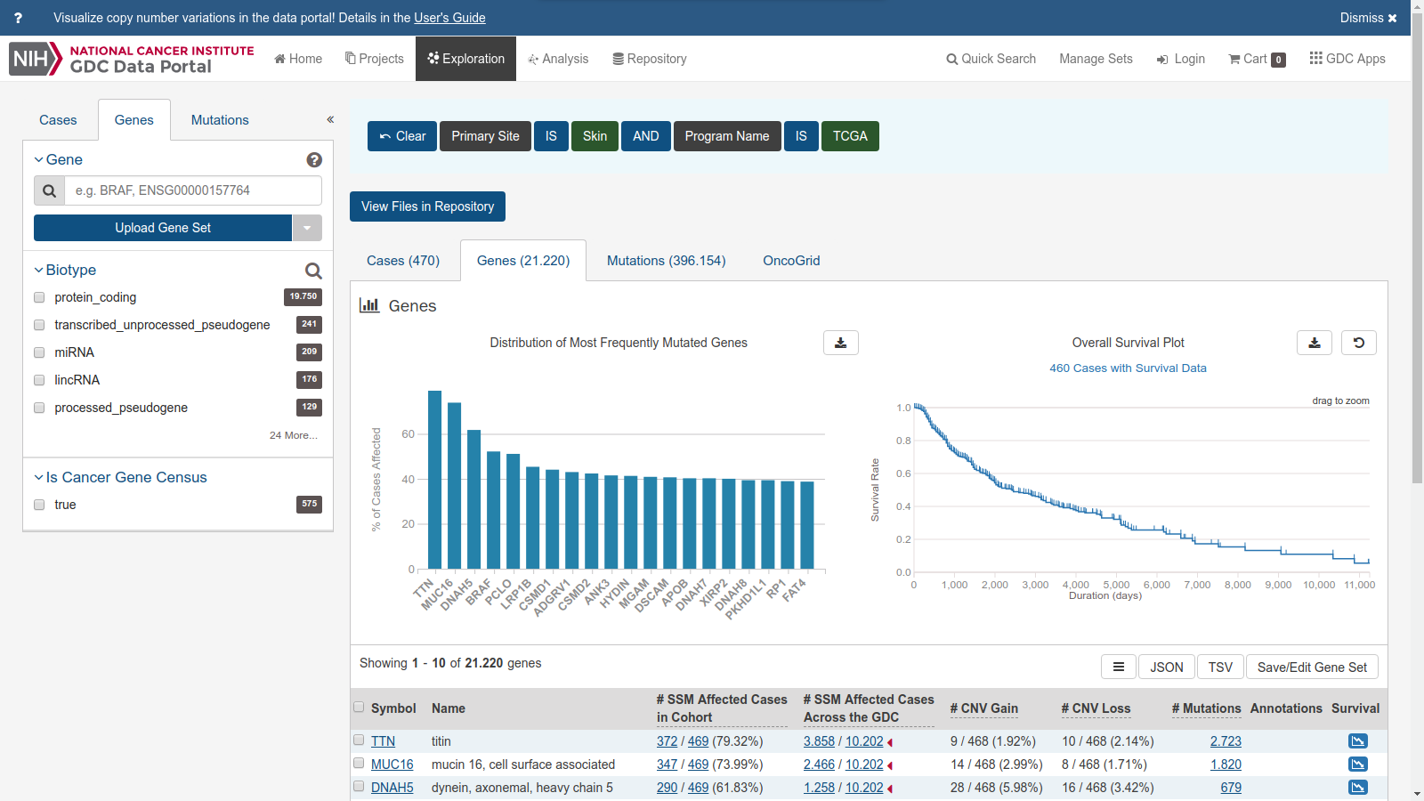

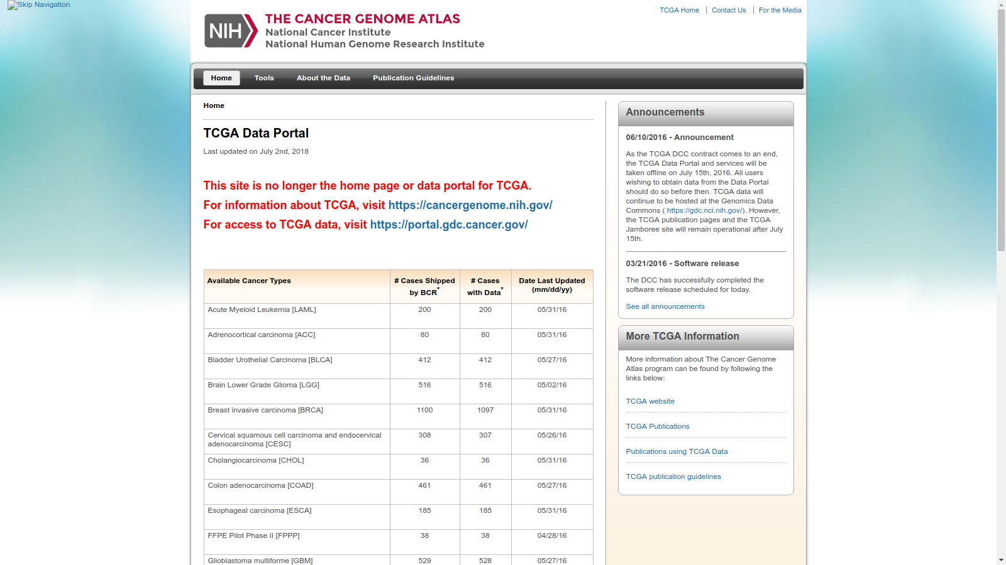

<https://portal.gdc.cancer.gov/>

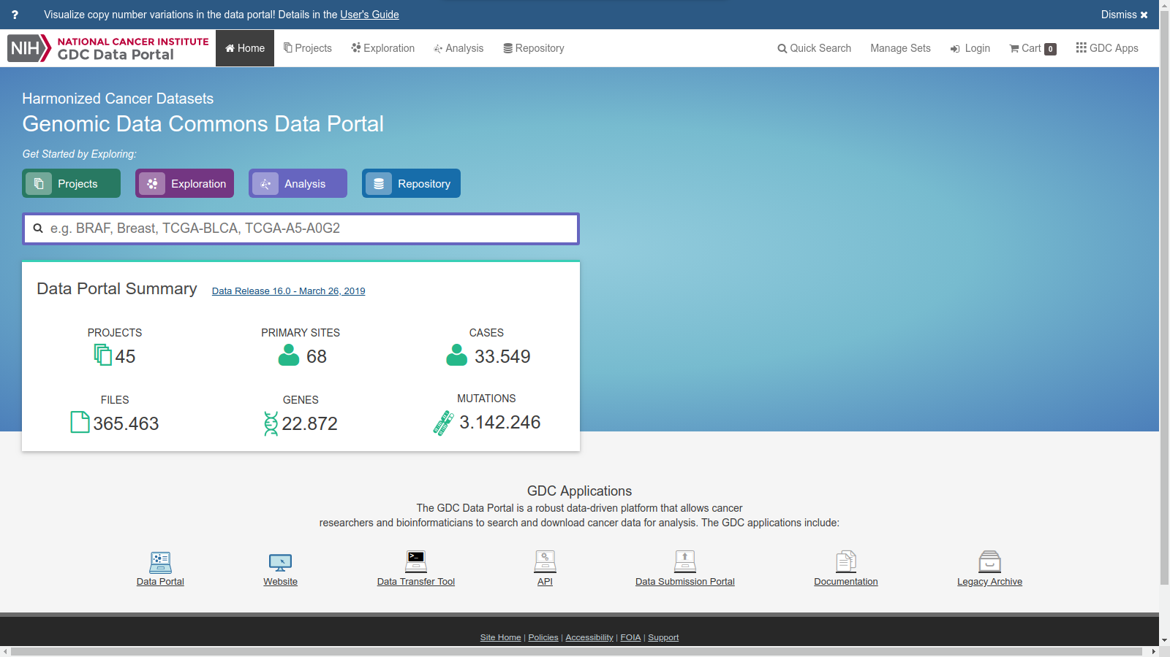

<https://www.ncbi.nlm.nih.gov/gene/29126>

This gene encodes an immune inhibitory receptor ligand that is expressed by hematopoietic and non-hematopoietic cells, such as T cells and B cells and various types of tumor cells. The encoded protein is a type I transmembrane protein that has immunoglobulin V-like and C-like domains. Interaction of this ligand with its receptor inhibits T-cell activation and cytokine production. During infection or inflammation of normal tissue, this interaction is important for preventing autoimmunity by maintaining homeostasis of the immune response. In tumor microenvironments, this interaction provides an immune escape for tumor cells through cytotoxic T-cell inactivation. Expression of this gene in tumor cells is considered to be prognostic in many types of human malignancies, including colon cancer and renal cell carcinoma. Alternative splicing results in multiple transcript variants. [provided by RefSeq, Sep 2015]

Este gene codifica um ligando do receptor inibitório imune que é expresso por células hematopoiéticas e não hematopoiéticas, tais como células T e células B e vários tipos de células tumorais. A proteï¿½a codificada ï¿½uma proteï¿½a transmembranar de tipo I que possui domï¿½ios semelhantes a imunoglobulina V e semelhantes a C. A interação desse ligante com seu receptor inibe a ativação de células T e a produção de citocinas. Durante a infecção ou inflamação do tecido normal, essa interação é importante para prevenir a autoimunidade, mantendo a homeostase da resposta imune. Em microambientes tumorais, essa interação fornece um escape imune para as células tumorais por meio da inativação das células T citotóxicas. A expressão deste gene em células tumorais é considerada prognóstica em muitos tipos de malignidades humanas, incluindo cancro do cólon e carcinoma das células renais. Resultados de splicing alternativo em múltiplas variantes de transcrição. [fornecido por RefSeq, setembro de 2015]

<https://portal.gdc.cancer.gov/exploration>

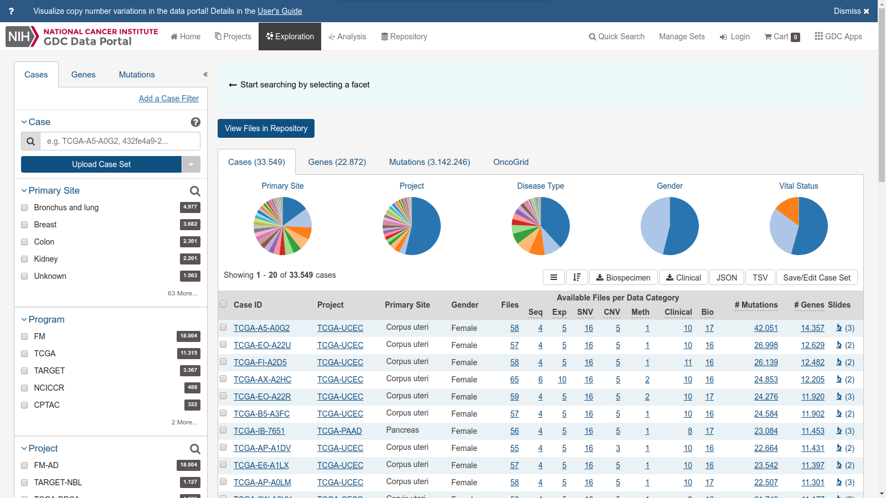

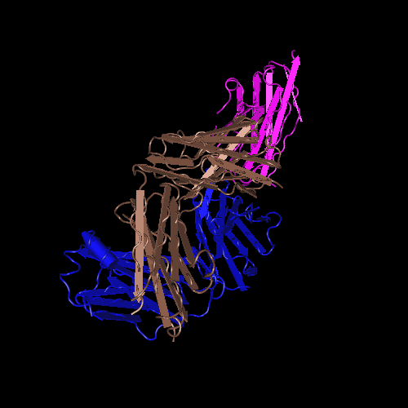

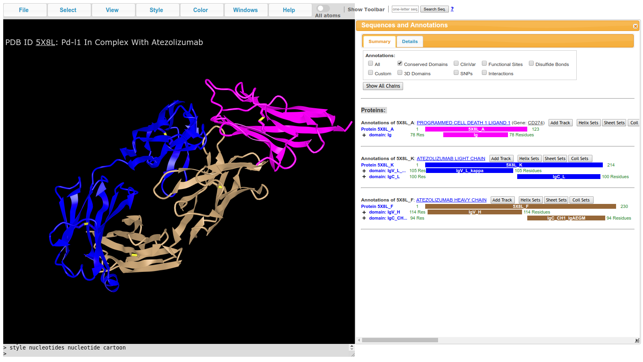

<https://www.ncbi.nlm.nih.gov/Structure/icn3d/full.html?&mmdbid=153795&bu=1&showanno=1>

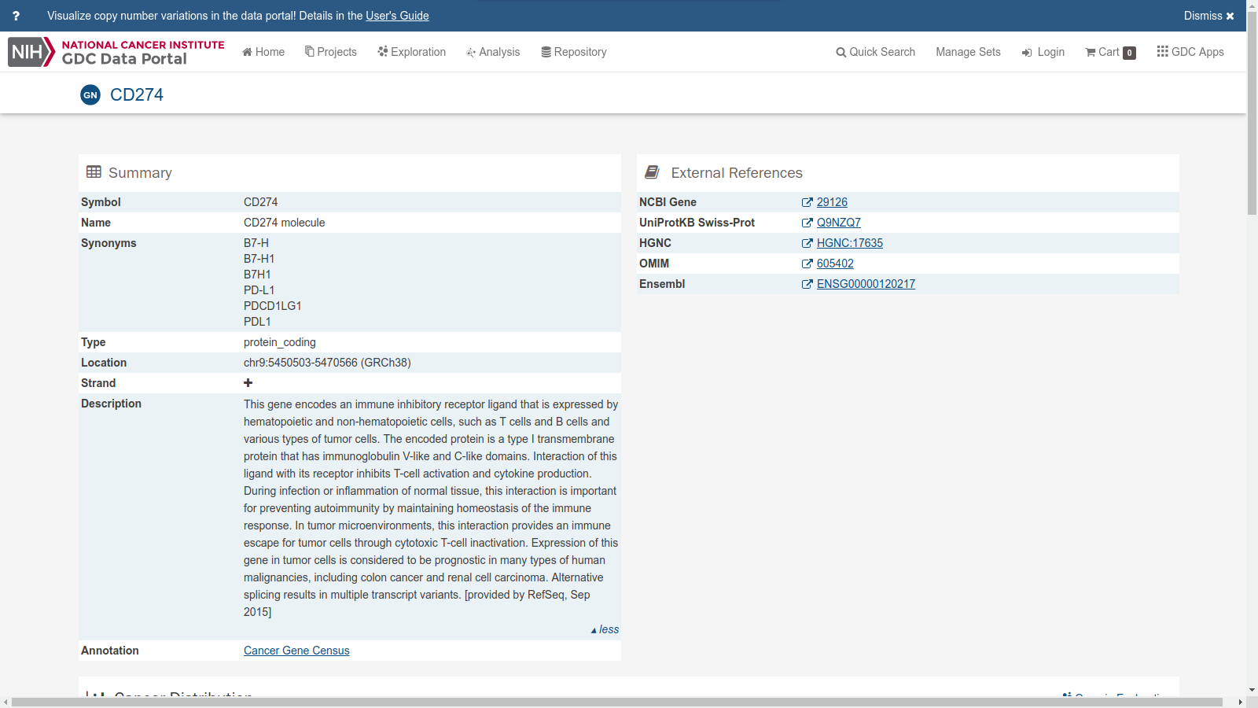

<https://portal.gdc.cancer.gov/genes/ENSG00000120217>

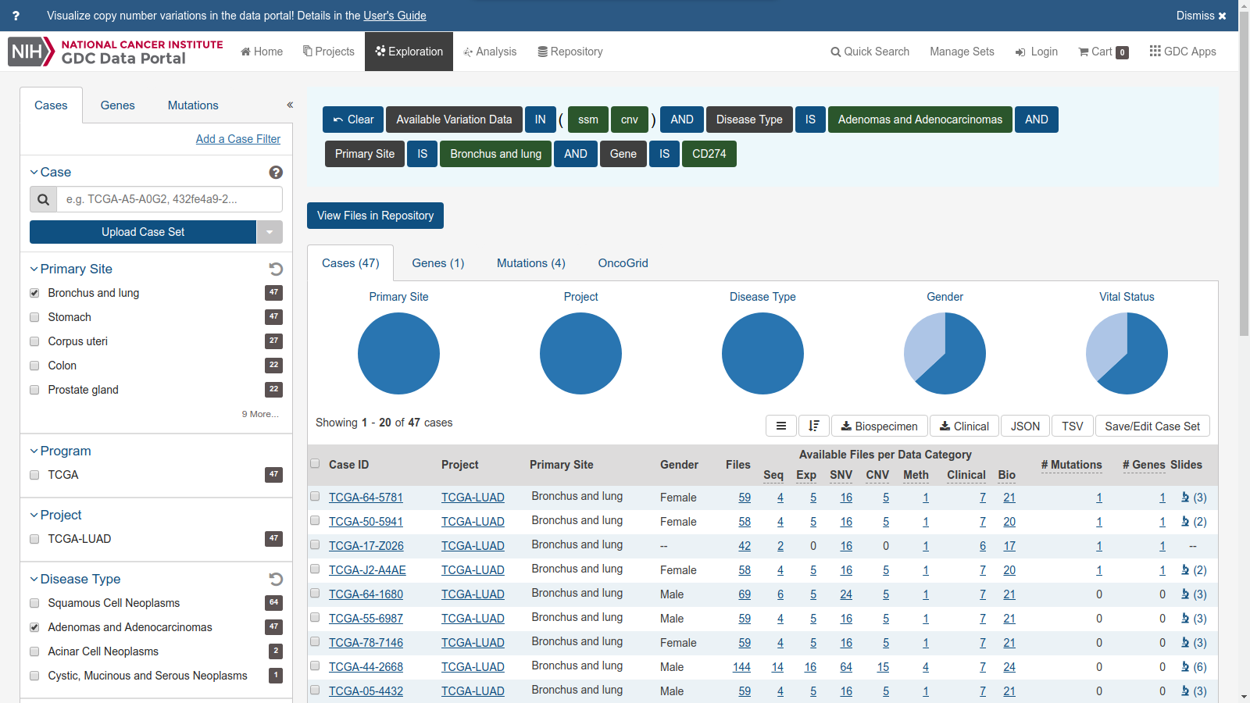

<https://portal.gdc.cancer.gov/exploration?cases_sort=%5B%5D&filters=%7B%22op%22%3A%22and%22%2C%22content%22%3A%5B%7B%22op%22%3A%22in%22%2C%22content%22%3A%7B%22field%22%3A%22cases.available_variation_data%22%2C%22value%22%3A%5B%22ssm%22%2C%22cnv%22%5D%7D%7D%2C%7B%22op%22%3A%22in%22%2C%22content%22%3A%7B%22field%22%3A%22cases.disease_type%22%2C%22value%22%3A%5B%22Adenomas%20and%20Adenocarcinomas%22%5D%7D%7D%2C%7B%22op%22%3A%22in%22%2C%22content%22%3A%7B%22field%22%3A%22cases.primary_site%22%2C%22value%22%3A%5B%22Bronchus%20and%20lung%22%5D%7D%7D%2C%7B%22op%22%3A%22in%22%2C%22content%22%3A%7B%22field%22%3A%22genes.gene_id%22%2C%22value%22%3A%5B%22ENSG00000120217%22%5D%7D%7D%5D%7D&searchTableTab=cases>

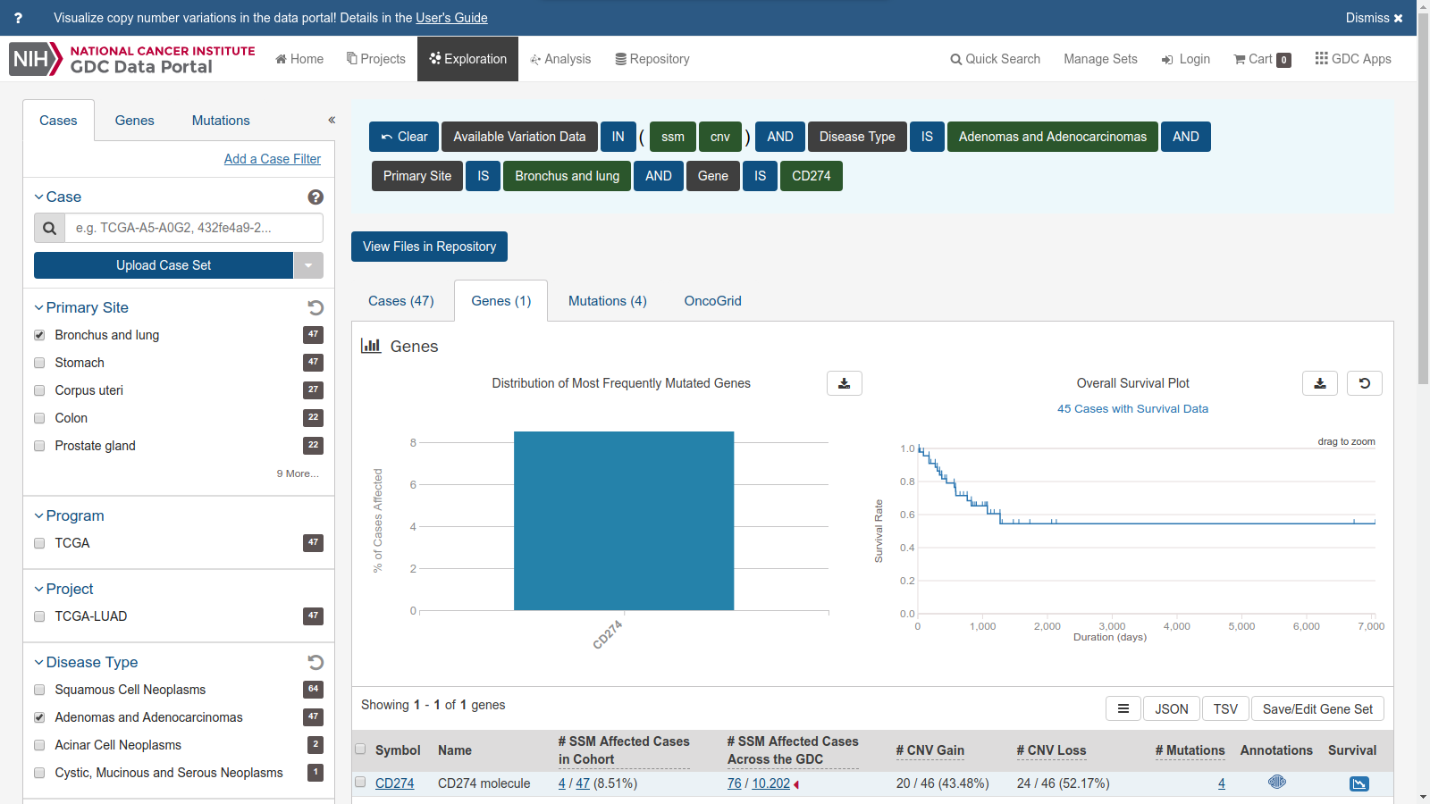

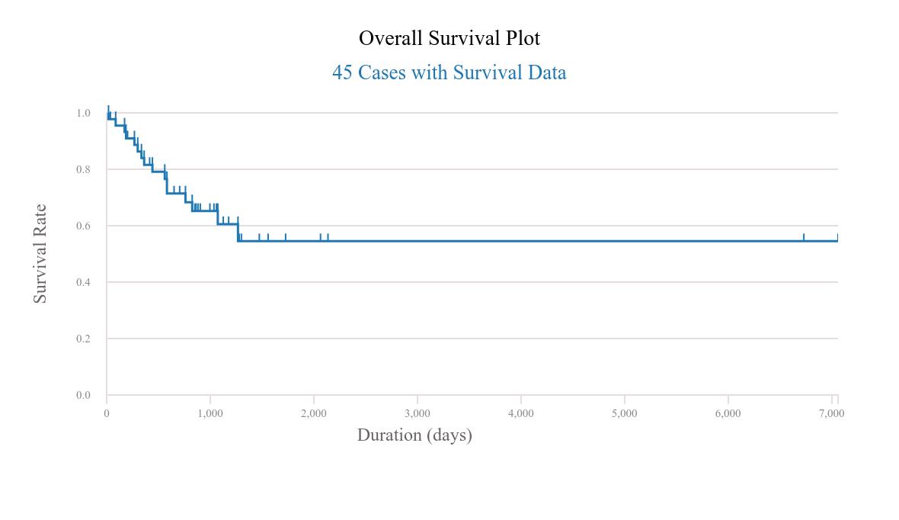

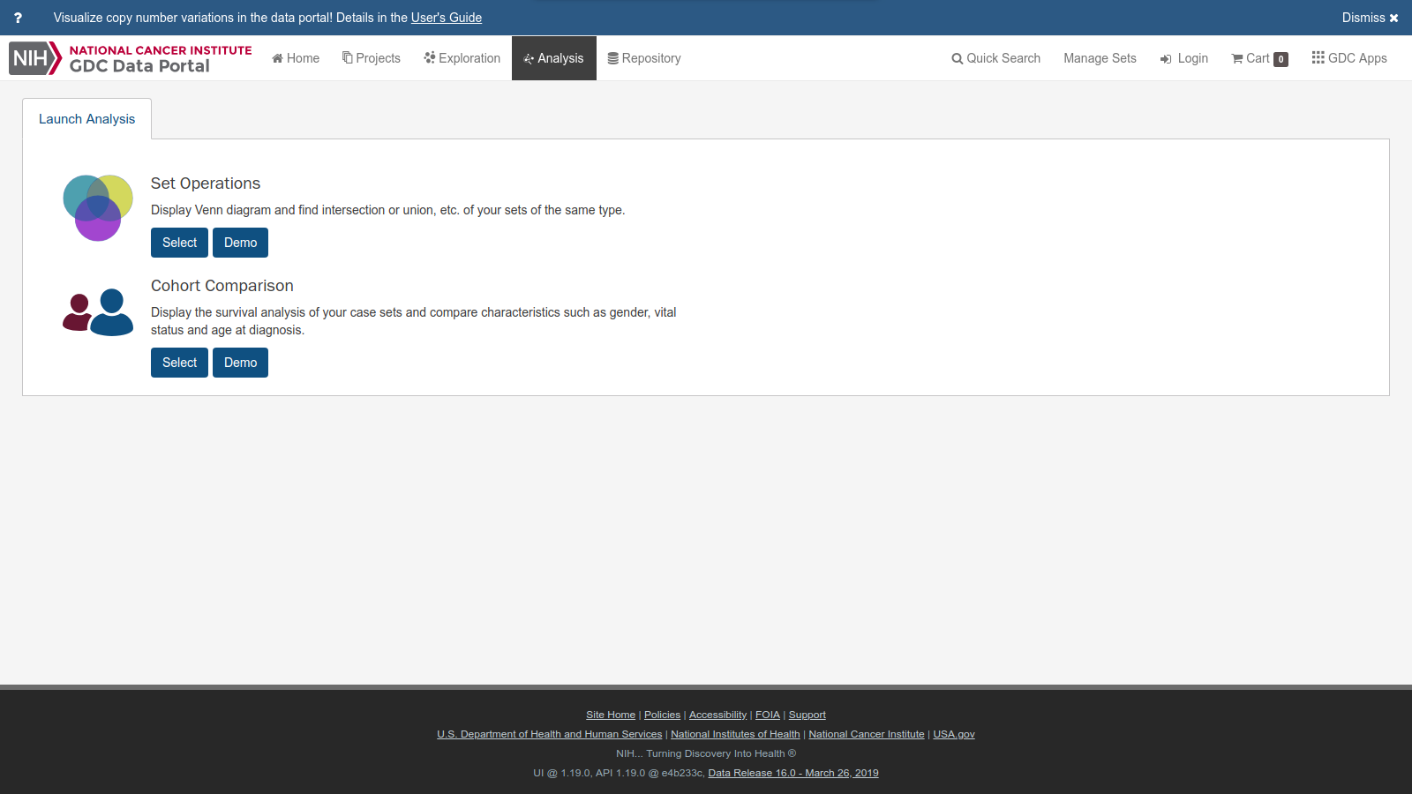

<https://portal.gdc.cancer.gov/analysis>